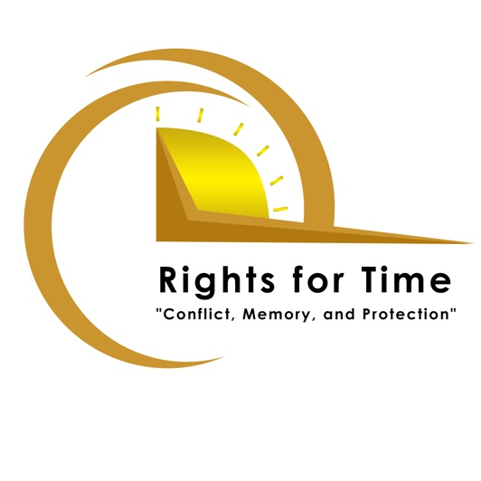
Call for Expressions of Interest – Artist/Curator team for commission on ‘time and trauma’
Value: £50,000 GBP
Due – 9 January 2023 : Expressions of Interest and approximate budget
- Final proposal of 2 pages and full budget to be submitted by invited parties 23 January
- Decisions early February 2023
The Rights for Time Research network is seeking expressions of interest for an artist/curator team to carry out a commission that explores the meaning of time amid the experience of harm. This commission is intended to give visual expression to work ongoing in the network, which interrogates notions of time and trauma in the Global South, outside of the typical humanitarian ‘crisis’ paradigm. In Palestine, for example, our work is redefining ‘trauma’ as an ongoing context rather than a single event that happens at a particular time. In Jordan we are exploring the historical (and changing) meaning of ‘refugee,’ and showing how changes in meaning over time effect perception, identity, and treatment. In Kenya we are showing how a new approach to sexual assault testimony reduces harm to survivors and can decrease the likelihood of repeat offenders. These and other projects all re-frame harms that are imagined having happened once, within a limited period of time, to show that by understanding harm more broadly through time, they can be better addressed and redressed.
As a complex concept, we seek a partner who can give visual expression to this intersection of time and trauma. (For more on the network see: www.rights4time.com)
Basics:
- Value: 50,000 GBP
- Expected Outputs: production of a curated series of visual art outputs for exhibition/performance/display; documentation of creative process; two public engagement events showcasing the creative work (one at artists’ discretion, one in Amman, Jordan), the publication of a high-quality catalogue (digital and in limited print).
- The definition of creative art output is quite broad, and can include video, performance, sculpture etc. However, work produced must ultimately be made available, and be fully complete, in a digital format.
- Eligibility: Artists and curator must be based in a country on the UK’s ODA-list (link)
  - Rights for Time already works in Jordan, Lebanon, Palestine, Kenya, Rwanda, and surrounding countries. While there is some preference for artists working in or engaging with these places, this should not limit interested teams.
- Team: can be as small as one artist/one curator and has no size limit besides the scope of funds and fair pay. The majority of the team must be resident in an ODA-list country.
- The rights to the work and any physical materials remain with the artists, with the network retaining limited usage and reproduction rights.

We would ask the commission team to become familiar with the Rights for Time projects. However, the degree to which the Network’s projects are referenced or included remains up to the commission team.
Timeline
For financial reasons a significant portion of the budget must be spent, and locations confirmed before March 2023. This may include artist commissions, materials expenses, The exhibitions can be held, and catalogue produced later, allowing time for work to be produced, but no later than March 2024.
Expressions of Interest should
- Be no more than 2 pages (excluding team CVs)
- Include details of:
  - The commission team (who need to indicate their availability for the proposed work)
    - Roles and one sentence of relevant experience of each team member
    - CV of all proposed participants (in addition to 1-page expression of interest)
  - Event locations (with preference for at least one public or open-to-the-public institution)
  - Production Timeline
  - Key concepts and overarching vision of the team (250 words)
  - Basic budget (areas of spend, i.e., materials/equipment, artist/curator fees, travel, consumables, etc.)
Expressions of interest should be sent directly to: rightsfortime@contacts.bham.ac.uk
Dossiers should be sent before 23:59 UK time on January 9

